# Assignment – 4

Write a program using pthreads to demonstrate the reader writer synchronization problem. Implement appropriate synchronization. Show the different results with and without synchronization

Code :

#include <stdio.h>

#include <pthread.h>

#include <unistd.h>

#define NUM_READERS 5

#define NUM_WRITERS 5

#define MAX_EXECUTIONS 5

int shared_variable = 0;

pthread_mutex_t mutex = PTHREAD_MUTEX_INITIALIZER; pthread_cond_t readers_condition = PTHREAD_COND_INITIALIZER; pthread_cond_t writers_condition = PTHREAD_COND_INITIALIZER;

int reader_executions = 0; int writer_executions = 0;

void* reader(void* arg) {

int id = *((int*)arg);

while (reader_executions < MAX_EXECUTIONS)

{

printf("Reader %d reads: %d\n", id, shared_variable); reader_executions++;

sleep(1);

}

return NULL;

}

void* writer(void* arg) {

int id = *((int*)arg);

while (writer_executions < MAX_EXECUTIONS)

{

shared_variable++; printf("Writer %d writes: %d\n", id, shared_variable); writer_executions++;

sleep(1);

}

return NULL;

}

int main() {

pthread_t readers[NUM_READERS]; pthread_t writers[NUM_WRITERS]; int reader_ids[NUM_READERS]; int writer_ids[NUM_WRITERS];

for (int i = 0; i < NUM_READERS; i++) {

reader_ids[i] = i + 1;

pthread_create(&readers[i], NULL, reader, &reader_ids[i]);

}

for (int i = 0; i < NUM_WRITERS; i++) {

writer_ids[i] = i + 1;

pthread_create(&writers[i], NULL, writer, &writer_ids[i]);

}

for (int i = 0; i < NUM_READERS; i++) { pthread_join(readers[i], NULL);

}

for (int i = 0; i < NUM_WRITERS; i++) { pthread_join(writers[i], NULL);

}

return 0;

}

Output :

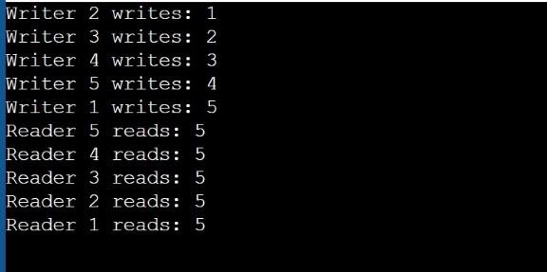

Code :

#include <pthread.h>

#include <semaphore.h>

#include <stdio.h>

sem_t wrt; pthread_mutex_t mutex; int balance = 1000; // Initial balance

void *credit(void *cno) { sem_wait(&wrt);

balance += 100; // Credit operation

printf("Credit %d: New balance is %d\n", (*((int *)cno)), balance); sem_post(&wrt);

}

void *debit(void *dno) { sem_wait(&wrt);

balance -= 100; // Debit operation

printf("Debit %d: New balance is %d\n", (*((int *)dno)), balance); sem_post(&wrt);

}

void *reader(void *rno) { pthread_mutex_lock(&mutex);

printf("Reader %d: Current balance is %d\n", (*((int *)rno)), balance);

pthread_mutex_unlock(&mutex);

}

int main() { pthread_t readers[5], writers[5]; pthread_mutex_init(&mutex, NULL);

sem_init(&wrt, 0, 1);

int rids[5] = {1, 2, 3, 4, 5}; // Reader IDs

int wids[5] = {1, 2, 3, 4, 5}; // Writer IDs

for (int i = 0; i < 5; i++) {

pthread_create(&readers[i], NULL, reader, &rids[i]); pthread_create(&writers[i], NULL, credit, &wids[i]);

}

for (int i = 0; i < 5; i++) { pthread_join(readers[i], NULL); pthread_join(writers[i], NULL);

}

pthread_mutex_destroy(&mutex); sem_destroy(&wrt);

return 0; }

Output :

